- Purpose

The purpose of this procedure is to define the process required to lock out the mud tank #2 at the Manufacturing facility.

- Scope

This procedure applies to all maintenance workers.

- Responsibility

Maintenance and Production

- Safety Considerations

Safety glasses and appropriate safety apparel is to be worn at all times.

Safety is a condition of employment. Employees are not authorized to work in an unsafe manner and are prohibited from harming the environment of the facility or community.

- Materials/Equipment

- Lock
- Tag
- Lock out device

- Procedure

The proper process to lockout Mud Tank #2 (Asset Tag #10127) is as follows:

- Notify all affected employees that the machine is being taken out of production. Lead Operator will be responsible for taking the tank out of production and notifying maintenance that tank is available for work. Procedure Starting and Stopping Digesters (Manuf-Dig-05) for both Liquid and Salt side Digesters should be followed before beginning lock out tag procedure for Mud Tank #1

- Locate disconnect for Mud Tank #2 (Asset Tag #10127) D1-A1
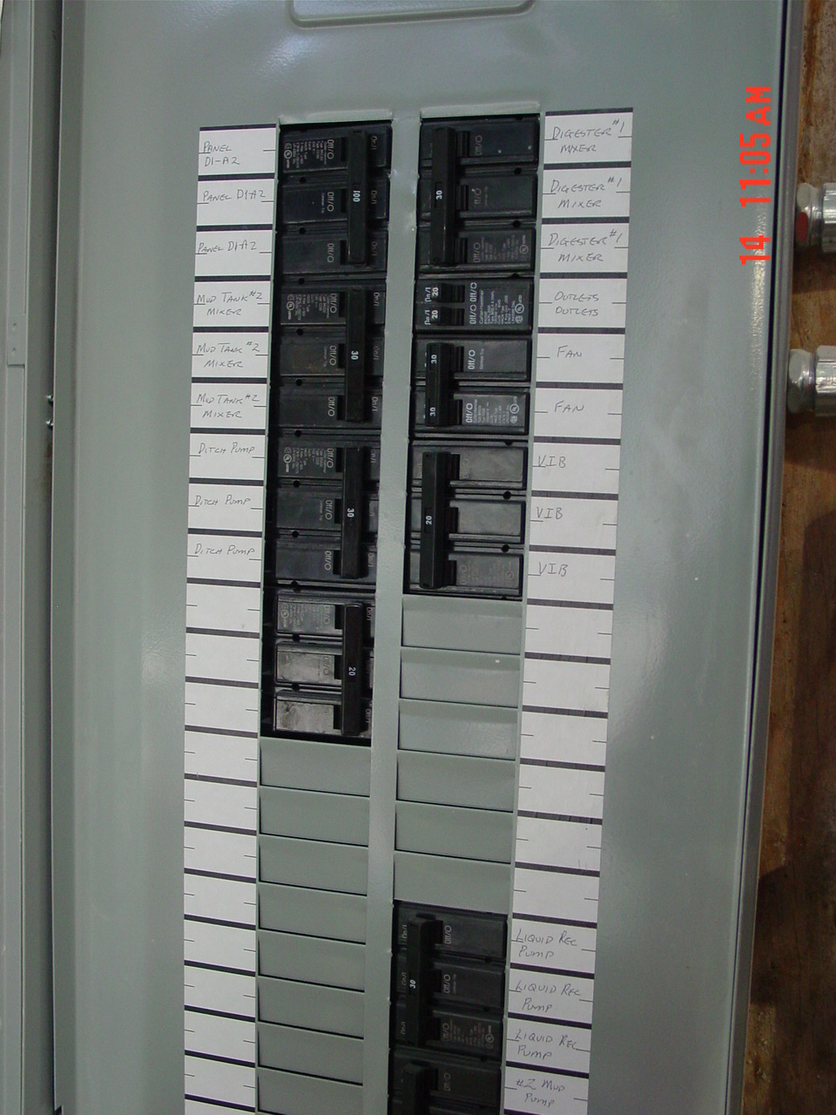
- Turn disconnect to the off position
- Install multi lockout breaker device
- ID tag with name, date and time
- Test start switch to ensure that Mud Tank #2 (Asset Tag #10127) agitator is not operational Light flashing should indicate that the agitator is in the off position
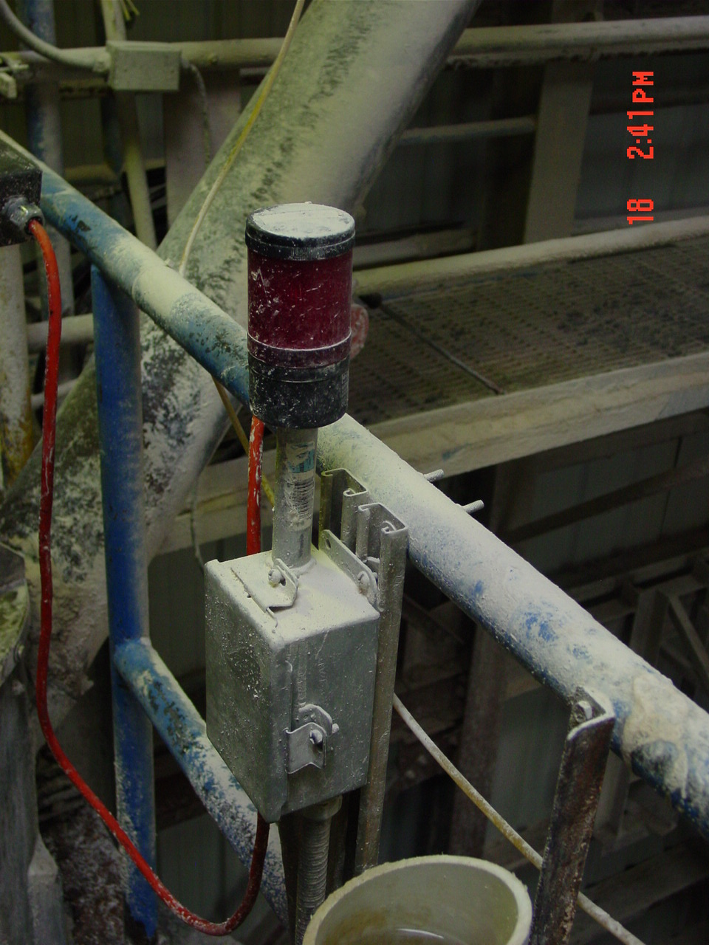.
- Close valve connecting Mud Tank #1 (Asset Tag #10128) and Mud Tank #2 (Asset Tag #10127) and lock out with appropriate lock out device
- Install multi lockout valve device
- ID tag with name, date and time
- Close 1” steam valve supplying steam to the Mud Tank
- Install multi lockout valve device
- ID tag with name, date and time

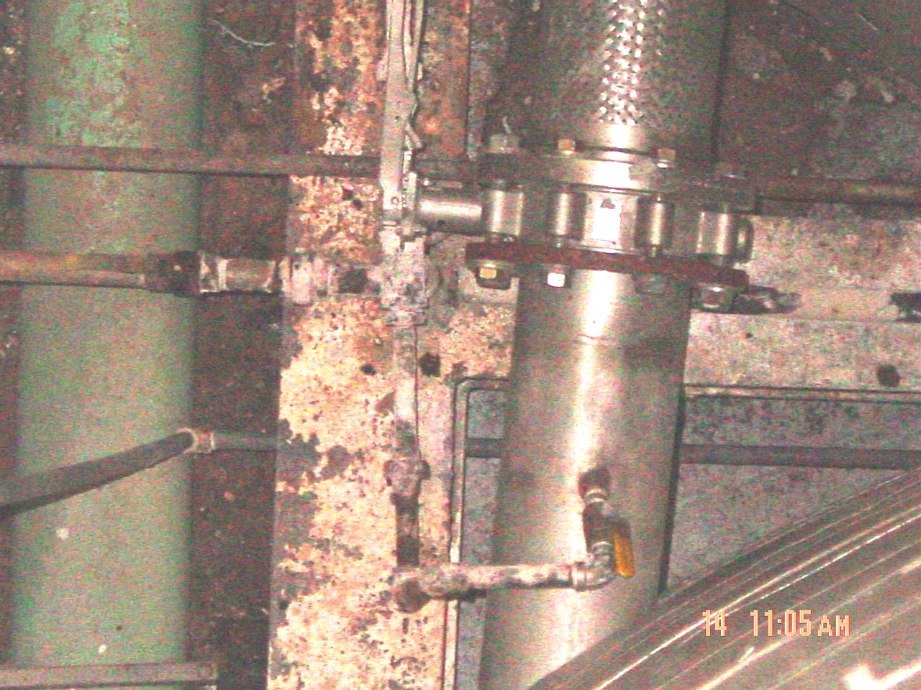

- Once all entry points and agitator is locked out confined space entry form should be completed (See procedure Confined Space Entry QA-HLTH-CSE) in preparation for removing hatch. Never reuse gasket when removing hatch to minimize the potential for leaks around hatch.

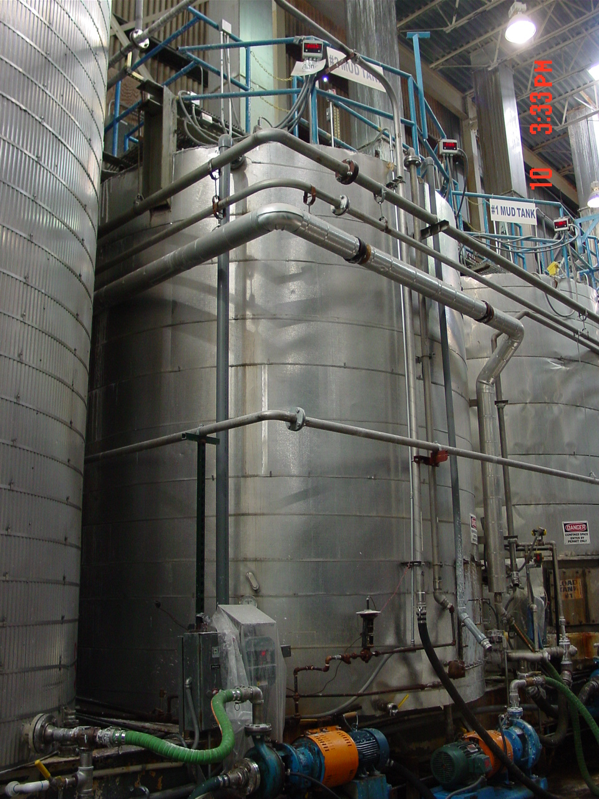

Proper procedure to return equipment to operation:

- Make sure all work is complete and all tools and maintenance equipment has been removed from the machine.
- Notify all affected employees that equipment is about to be put back into service.
- Remove ID tag with name, date and time
- Remove multi lockout device
- Turn disconnect to the on position
- Ensure that equipment is operational and available to be returned to production

- Reference Documents

N/A

- Change Information

Document review- updated format using new template and numbering system.

